Date of Issuance: July 31, 2026

INFORMATION

WANTED

$30,000 REWARD

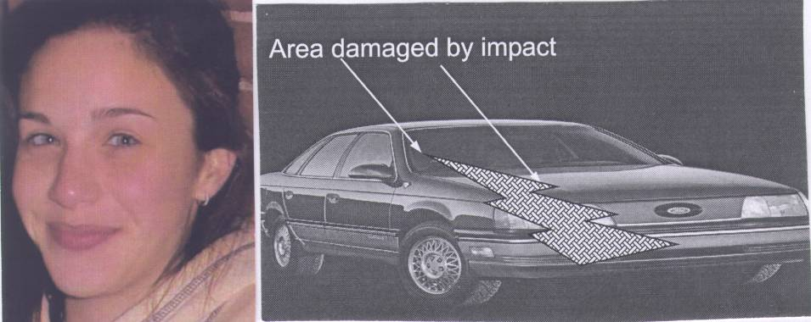

JESSICA SAVARESE (14) LOOKING FOR A 1989-90-1991 FORD TAURUS

LEAVING SCENE / ACCIDENT
Crime Stoppers and the Nassau County Police Department are seeking the Public’s help in identifying this vehicle that was involved in a fatal hit and run, involving a pedestrian, in Franklin Square.

On May 7, 2004 at about 11:00 P.M., westbound on Hempstead Turnpike at Claflin Blvd, the above pictured victim was struck by a vehicle that left the scene. The victim died as a result of her injuries.

This type of vehicle (photo) is wanted in connection with this incident. The car involved will be missing a passenger side headlight and cornering light. It will probably have passenger side damage. The color of the car is unknown.

The family and friends of Jessica Savarese are offering a reward of $30,000.00 to anyone who provides information that results in the arrest and conviction of the person(s) involved in this incident. In addition, Crime Stoppers is offering a reward of $2,000.00 for information that leads to an arrest.

Anyone with information is asked to call Crime Stoppers at our 24 hr. toll free hotline 1-800-244-TIPS. Detective Ferrucci (Homicide) investigating, 516-573-7788.

All calls are confidential and you do not have to appear in court.
www.co.nassau.ny.us/wanted

